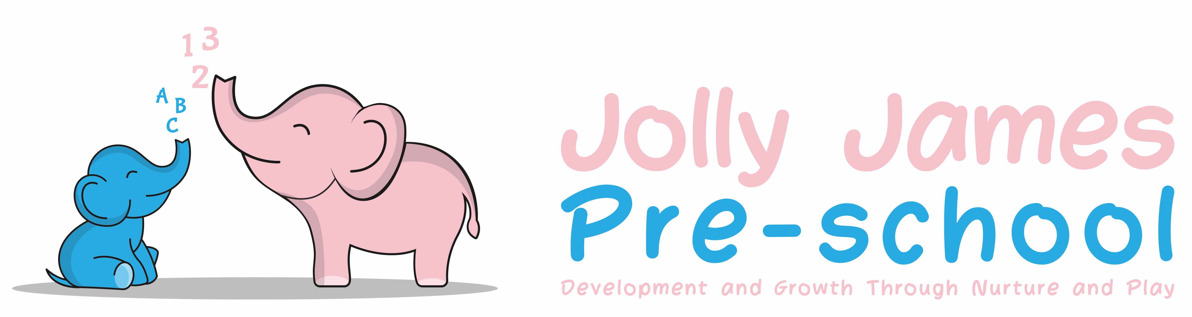
Managing children with Allergies,
Or who are sick or infectious

Policy Statement

We provide care for healthy children through preventing cross infection of viruses and bacterial infections and promote health through identifying allergies and preventing contact with the allergenic substance.

Procedures for children who are sick or infectious

- If a child appears unwell during the day – have a temperature, sickness, diarrhoea or pains, particularly in the head or stomach – the manager or key worker calls the parents and asks them to collect the child, or send a known carer to collect on their behalf
- If a child has a temperature, they are kept cool, by removing top clothing and kept away from draughts
- Temperature is taken using a ‘digital thermometer’ kept in the medicine box
- In extreme cases of emergency the child should be taken to the nearest hospital and the parent informed
- Parents are asked to take their child to the doctor before returning them to Pre-school; we can refuse admittance to children who have a temperature, sickness and diarrhoea or a contagious infection or disease
- Where a child has had sickness or diarrhoea, we ask for them to be kept at home for 48 hours after the last episode of sickness/diarrhoea.
- The setting has a list of excludable diseases and current exclusion times. The full list is obtainable from www.hpa.org.uk/webc/HPAwebFile/HPAweb_C/1194947358374

- Parents will be informed of any contagious conditions by posters or notices that we will post on the door for example, chicken pox. Any serious conditions we will also notify parents by email or letter.

Reporting of infectious diseases

- If a child or adult is diagnosed suffering from a notifiable disease under the Health Protection (Notification) Regulations 2010, the GP will report this to the Health Protection Agency
- When the setting becomes aware, or is formally informed of the notifiable disease, the group leader informs Ofsted and acts on any advice given by the Health Protection Agency

HIV/AIDS/Hepatitis procedure

- HIV virus, like other viruses such as Hepatitis A, B and C, are spread through body fluids. Hygiene precautions for dealing with body fluids are the same for all children and adults
- Single-use vinyl gloves and aprons are worn when changing children’s nappies, pants and clothing that are soiled with blood, urine, faeces or vomit
- Protective rubber gloves are used for cleaning/sluicing clothing after changing
- Soiled clothing is bagged for parents to collect
- Spills of blood, urine, faeces or vomit are cleared using mild disinfectant solution and mops; any cloths used are disposed of with the clinical waste
- Tables and other furniture, furnishings or toys affected by blood, urine, faeces or vomit are cleaned using a disinfectant

Nits and Head lice

- Nits and head lice are not an excludable condition, although in exceptional cases a parent may be asked to keep the child away until the infestation has cleared
- On identifying cases of head lice a notice will be placed on the setting door to inform all parents, they will be asked to check and treat their child and all the family if they are found to have head lice

Procedures for children with allergies

- When parents start their children at the setting they are asked if their child suffers from any known allergies. This is recorded on the registration form.
- If a child has an allergy, a risk assessment/health care form is completed to detail the following:
- The allergen (i.e. the substance, material or living creature the child is allergic to such as nuts, eggs, bee stings, cats etc)
- The nature of the allergic reaction e.g. anaphylactic shock reaction, including rash, reddening of the skin, swelling, breathing problems etc
- What to do in case of allergic reactions, any medication used and how it is to be used (e.g. Epipen)
- Control measures – such as how the child can be prevented from contact with the allergen
- Review

- This form is kept in the child’s personal file, a copy is displayed where staff can see it.
- Parents train staff in how to administer special medication in the event of an allergic reaction.
- Generally, no nuts or nut products are used within the setting.
- Parents are made aware so that no nut or nut products are accidentally brought in, for example to the party or lunch club.

Insurance Requirements for children with allergies and disabilities

- The insurance will automatically include children with any disability or allergy but certain procedures must be strictly adhered to as set out below. For children suffering life threatening conditions, or requiring invasive treatments; written confirmation from your insurance provider must be obtained to extend the insurance.

Oral medication

Asthma inhalers are now regarded as ‘oral medication’ by insurers and so documents do not need to be forwarded to the insurer.

- Oral medications must be prescribed by a GP and have the child name and date on.
- The setting must be provided with clear written instructions on how to administer such medication
- All risk assessment procedures need to be adhered to for the correct storage and administration of the medication
- The setting must have the parents or guardians prior written consent. This consent must be kept on file

Further Guidance

- Managing Medicines in Schools and Early Years Settings (DfES 2005)

Other useful Pre-School Learning Alliance publications

- Good Practise in Early Years Infection Control (2009)

Signed By; Hayley Culverwell, Manager

Date to be reviewed; 21/8/24

