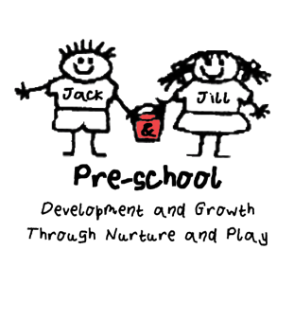
Policy Statement on the Recruitment of Ex-offenders

- As an organisation using the Disclosure and Barring service to assess applicant’s suitability for positions of trust, Jack & Jill Pre-school complies fully with the DBS Code of Practise and undertakes to treat all applicants for positions fairly. It undertakes not to discriminate unfairly against any subject of a Disclosure on the basis of a conviction or other information revealed

- Jack & Jill Pre-school is committed to the fair treatment of its staff, potential staff or users of its services, regardless of race, gender, religion, sexual orientation, responsibilities for dependants, age, physical/mental disability or offending background

- We have a written policy on the recruitment of ex-offenders, which is made available to all Disclosure applicants at the outset of the recruitment process

- We actively promote equality of opportunity for all with the right mix of talent, skills and potential and welcome applications from a wide range of candidates, including those with criminal records. We select all candidates for interview based on their skills, qualifications and experience

- A Disclosure is only requested after a thorough risk assessment has indicated that one is both proportionate and relevant to the position concerned. For those positions where a Disclosure is required, all application forms, job adverts and recruitment briefs will contain a statement that a Disclosure will be requested in the event of the individual being offered the position

- Where a Disclosure is to form part of the recruitment process, we encourage all applicants called for interview to provide details of their criminal record at an early stage in the application process. We request that this information is sent under separate, confidential cover, to a designated person within Jack & Jill Pre-school and we guarantee that this information will only be seen by those who need to see it as part of the recruitment process

- Unless the nature of the position allows Jack & Jill Pre-school to ask questions about your entire criminal record, we only ask about “unspent” convictions as defined in the Rehabilitation of Offenders Act 1974

- We ensure that all those in Jack & Jill Pre-school who are involved in the recruitment process have been suitably trained to identify and assess the relevance and circumstances of offences. We also ensure that they have received appropriate guidance and training in the relevant legislation relating to the employment of ex-offenders, e.g. the Rehabilitation of Offenders Act 1974

- At interview, or in a separate discussion, we ensure that an open and measured discussion takes place on the subject of any offences or other matter that might be relevant to the position. Failure to reveal information that is directly relevant to the position sought could lead to withdrawal of an offer of employment

- We make every subject of a CRB Disclosure aware of the existence of the CRB Code of Practise and make a copy available on request

- We undertake to discuss any matter revealed in a Disclosure with the person seeking the position before withdrawing a conditional offer of employment

Having a criminal record will not necessarily bar you from working with us. This will depend on the nature of the position and the circumstances and background of your offences.

This Policy was adopted on (date) ____________________________________

Signed By______________________________________________________

Date to be reviewed______________________________________________

