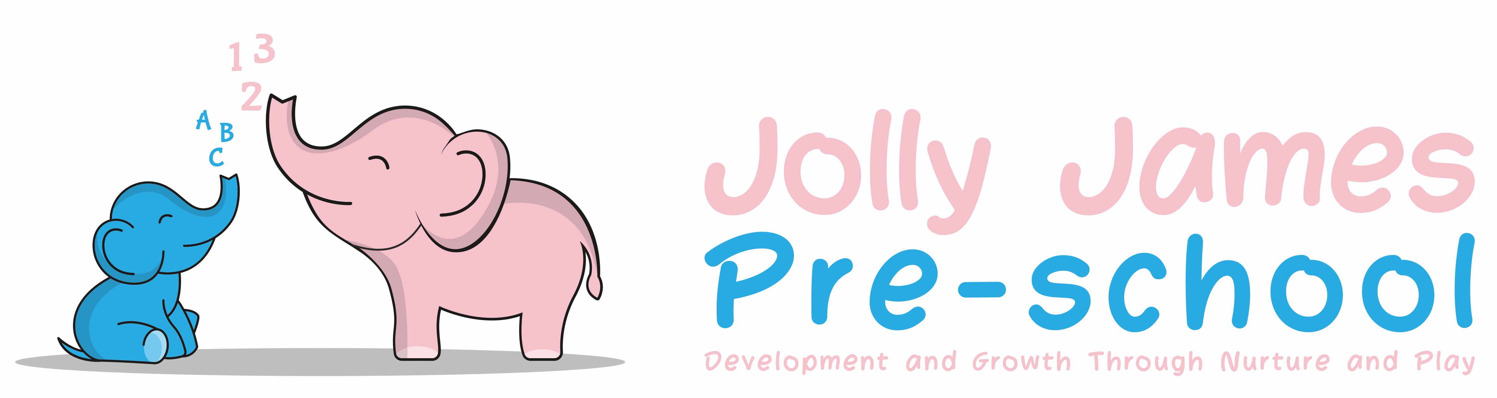
No Smoking, Alcohol and Banned Substances
Policy

No Smoking and No Vaping

Policy Statement

We comply with health and safety regulations and the welfare requirements of the EYFS in making Jolly James Pre-school a no-smoking and no-vaping environment.

Procedures

- All staff, parents and volunteers are made aware of our no-smoking policy.
- We display no-smoking signs.
- We actively encourage no-smoking and can help staff or parents by getting information if they are seeking it about where to get help to stop smoking.
- Staff who smoke do not do so during work hours. Unless on a break and off the premises.
- If it is necessary to smoke during their break, the staff member will make every effort to reduce the effect of the odour and lingering effects of passive smoking for children and colleagues.

Alcohol and Banned substances

Policy statement

In the event that a parent or staff member arrives at the setting in an unfit state due to alcohol or substance abuse the setting puts into practice agreed procedures.
We acknowledge that alcohol and substance abuse are often addictions which are difficult to manage and so we approach any incident in a non-judgemental manor and attempt to offer advice and support.

Procedures

- Staff are not permitted to consume alcohol during their contracted hours of work or to care for the children if they have consumed alcohol prior to commencing work.
- This also applies to all drugs other than those prescribed by a doctor and considered appropriate for intake whilst working with children.
- Staff will ensure that all medication is stored correctly.
- Management will respond to and investigate any complaint raised in relation to the alleged breaches to the welfare requirements.

If a member of staff is suspected of being unfit to care for children due to alcohol or substance abuse

- Should a member of staff be found under the influence of alcohol or drugs of any illegal form before or during the opening hours, they will be immediately asked to leave the premises and told to return home.
- This absence is classed as unauthorised and a dated record will be made of the incident and added to the member of staff record.
- The member of staff will receive no pay for the missed session.
- Advice and support will be offered to the member of staff.
- If such incidents are repeated or become a concern then we activate the Staff Disciplinary Procedure.

If a Parent/carer is suspected of being unfit to care for a child due to alcohol or substance abuse

- We will manage the incident tactfully to ensure that the professional relationship with the family is maintained.
- If a senior staff member has any concerns regarding the child’s welfare we would endeavour to speak to the child’s parent/carer about their child’s needs.
- We will ensure that there are two members of staff present when speaking to the parent so that staff should not jeopardise their own staff or that of others in these situations.
- In the event that a parent/carer arrives at the pre-school appearing to be under the influence of alcohol or drugs, we will ask that someone comes with the parent/carer to take responsibility of the child before the member of staff gives up their responsibility of the child.
- Should this not happen, although we have no legal right to withhold a child from their parent/carer, we however reserve the right to contact any relevant authorities that we feel appropriate, for example, the police or a partner etc. Any member of staff feeling under threat should contact the police.
- A full written report will be made of the incident.
- Depending on the circumstances First response will be notified.
Signed By: Hayley Culverwell, Manager

Date to be reviewed: 21/8/24

