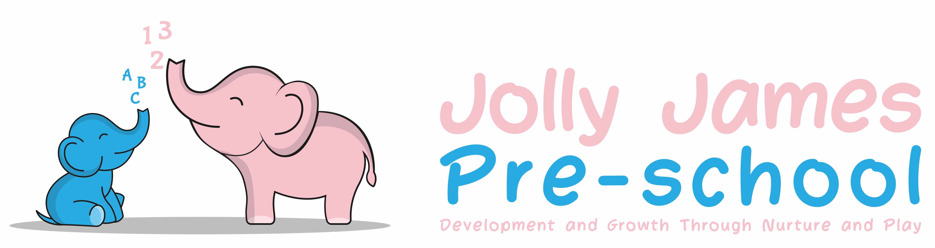
Safeguarding Children
Confidentiality Policy

Policy statement

At Jolly James Pre-school, staff and managers can be said to have a confidential relationship with families. It is our intention to respect the privacy of children and their parents and carers, while ensuring that they access high quality early years care and education in our setting.

We aim to ensure that all parents and carers can share their information in the confidence that it will only be used to enhance the welfare of their children. There are record keeping systems in place that meet legal requirements; means of storing and sharing that information take place within the framework of the Data Protection Act, Human Rights Act and Freedom of Information Act.

Procedures

- Any information that a parent shares with us is regarded as confidential. This information will not be passed on to other adults/agencies without the written agreement of parental consent
- Information shared between parents in a discussion or training group is usually bound by a shared agreement that the information is confidential to the group and not discussed outside of it
- Jolly James Pre-school cannot be held responsible for personal information shared by any parent with other parents, especially in cases where Pre-school staff have also been taken into confidence
- We will inform parents when we need to record confidential information beyond the general personal information we keep – for example with regard to any injuries, concerns or changes in relation to the child or the family, any discussions with parents on sensitive matters, any records we are obliged to keep regarding action taken in respect of child protection and any contact and correspondence with external agencies in relation to their child
- The Pre-school manager will explain the confidentiality procedures to any volunteers, parent helpers and students working in the Pre-school when they come into the setting for the first time. They will also be given the opportunity to read the policy for themselves.
- Knowledge gained or overheard by parent helpers within any session is regarded as confidential and must not be discussed with anyone outside of that session
- Public disclosure of any confidential information discussed on or off the Pre-school setting regarding a staff member, volunteer helper, parent or child will result in disciplinary action being taken
- We keep all records securely

Access to records procedure

Parents may request access to any confidential records held on their child and family following the procedure below:
- Any request to see the child’s personal file by a parent or person with parental responsibility must be made in writing to the Pre-school manager. Parents can verbally ask to see a developmental file such as observations.
- We will commit to provide access within 14 days, although this may be extended
- The Pre-school manager will prepare the file for viewing
- All third parties are written to, stating that a request for disclosure has been received and asking for their permission to disclose to the person requesting it. Copies of the letters are retained on file
- ‘Third parties’ include all family members who may be referred to in the records
- It also includes workers from any other agency, including social services, the health authority, etc. It is usual for agencies to refuse consent to disclose, preferring the individual to go directly to them
- When all the consent/refusals to disclose have been received these are attached to the copy of the request letter
- A photocopy of the complete file is taken
- The Pre-school manager will go through the file and remove any information which a third party has refused consent to disclose. (In some situations, this may have to be done with a thick black marker to score through every reference to the third party and information they have added to the file)
- What remains is the information recorded by the setting, detailing the work initiated and followed by them in relation to confidential matters. This is called the ‘clean copy’
- The ‘clean copy’ is photocopied for the parents who are then invited into discuss the contents. The file will never be given straight over, but will be gone through by the Pre-school manager, so that it can be explained
- Legal advice may be sought before sharing a file, especially where the parent has possible grounds for litigation against the setting or another (third party) agency
- Written permission must be obtained from Ofsted if children’s records are to be removed from the premises, to follow the requirements that certain documents must remain on the premises at all times

Legal Framework

- Data Protection Act 1998
- Human Rights Act 1998
- Freedom of Information Act

Signed By;

Date to be reviewed______________________________________________

