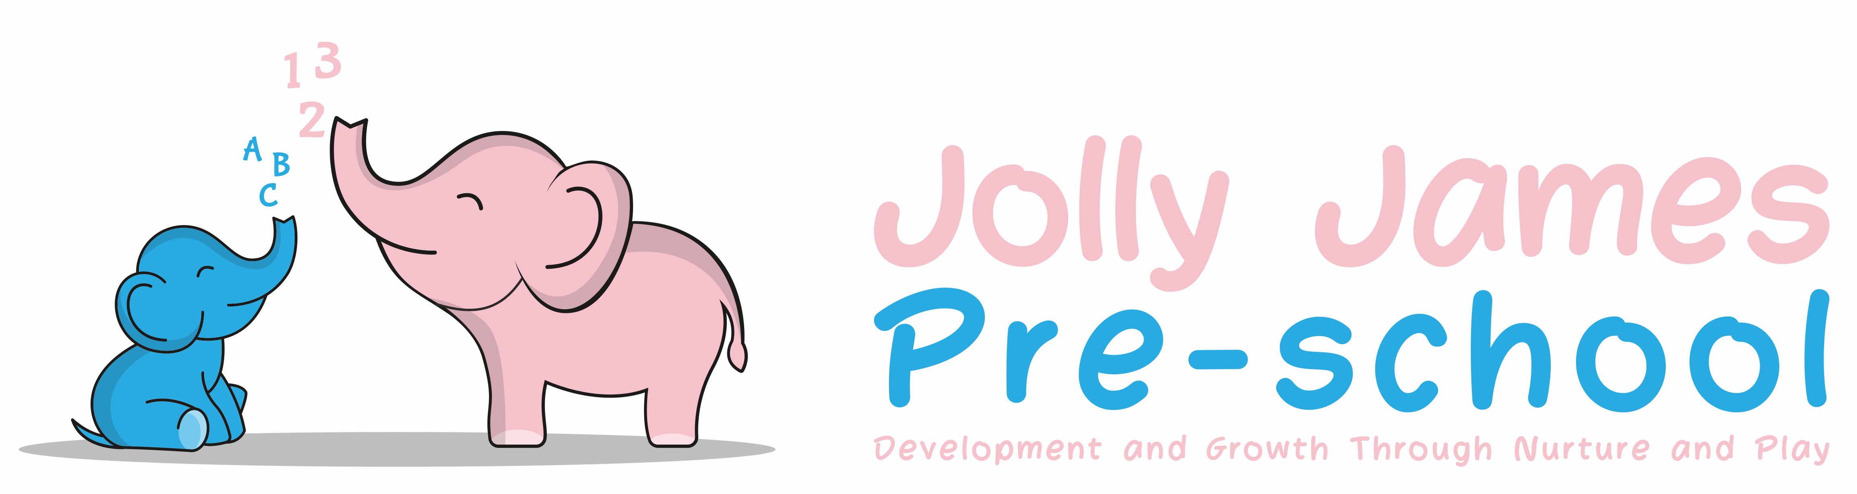
Social Networking, Mobile Phone and Camera
Policy

Social Networking

At Jolly James Pre-School we are aware that social networking sites are becoming very popular and are a way for people to stay in touch with friends. We are also very aware that through the open nature of such sites it is possible for third parties to access this information.

The intention of this policy is to make staff and parents aware of any implications that may arise from using these sites and not to stop them conducting legitimate activities on the internet.

Social networking sites allow photographs, videos and comments to be shared with many other users. It is not appropriate to share work related information whether written or pictorial in this way and staff members should remember and respect the privacy and feelings of others.

Staff are in a professional position and are responsible for the care and education of children. Therefore they must not engage in activities on the internet which might bring the setting and its staff into disrepute.

Aim

- To maintain our duty to safeguard children
- That the reputation of the setting is not affected in any way

Procedures

- We recommend that members of staff are not friends with parents on social networking sites, however if a member of staff allows a parent to view their page they must remain professional at all times
- They must ensure that there will be no uploading of photos of staff, children and their families on any site
- All staff and parents should bear in mind that information they share through social networking sites, even though they are on private spaces, are still subject to copyright, data protection and freedom of information legislation, the safeguarding vulnerable groups act 2006 and other legislation.
- If any of the above points are not followed, then the member of staff involved could face disciplinary action which could result in dismissal.

Mobile Phones

At Jolly James Pre-school we take steps to ensure that there are effective procedures in place to protect the children in our setting from the unacceptable use of mobile phones and cameras in the setting.

Procedures

This policy applies to staff, volunteers and visitors.

- All staff mobile phones will be kept in the office for the duration of the session and must not be carried about in person during the working hours, with exception of the settings mobile phone
- In the event of an emergency, personal mobile phones may be used in the privacy of the office, with permission from the manager
- Members of staff ensure that the telephone number of the setting is known to immediate family and other people who need to contact them in an emergency
- If members of staff take their own mobile phones on outings, for use in the case of an emergency, they must not make or receive calls as this will distract them
- Members of staff will not use their personal mobile phones for taking photographs of children on outings
- Parents and visitors are requested not to use their mobile phones whilst on the premises. Visitors will be advised of a quiet space where they can use their mobile phones, where there are no children present
- All visitors and volunteers will also be asked to leave their bags/phones in the office
- The police will be informed immediately if inappropriate use of mobile phones is suspected
- If any of the above points are not followed, then the member of staff involved could face disciplinary action which could result in dismissal.

Cameras/Tablet

At Jolly James Pre-school photographs are taken for the purpose of recording a child or group of children participating in activities or celebrating their achievements and are an effective way of recording their progression in the Early Years Foundation Stage.

It is essential that photographs are taken and stored appropriately to safeguard the children in our care.

Procedures

- Only the designated Jolly James Pre-school camera/tablets are to be used to take any photos within the setting or on outings
- Members of staff must not bring their own cameras or video recorders into the setting
- Photographs and recordings of children are only taken for valid reasons, i.e. to record their learning and development, or for displays within the setting
- All staff are responsible for location of the camera/tablet, which should be placed within the locked filing cabinet at the end of the day
- Images taken and stored on the camera must be downloaded on the site computer only as soon as possible
- Under no circumstances must cameras/tablets of any kind be taken into the toilet area without prior consultation with the person in charge. If photos need to be taken into the toilet area i.e. photographs of the children washing their hands, then the person in charge must be asked and another member of staff present whilst carrying out this kind of activity. At all times the camera must be placed in a position where it can be seen
- Where parents request permission to photograph or record their own children at special events, permission must be gained from all parents for their children to be included
- Photographs and recordings of children are only taken of the children if there is written permission to do so in the child’s registration form

Online Learning Journeys

Jolly James Pre-school have invested in the use of tablets to support the use of Tapestry for the online learning journeys of all children in the setting. Tapestry is a very secure online system (their data centre is ISO27001 accredited, and their staff are security vetted to BS27001 standard) run by the Early Years Foundation Stage Forum (FSF). Each tablet will be in the setting, loaded with the Tapestry application for staff to use. Tapestry is password protected, each member of staff having their own logon id and password. The tablets will be used to record observations and take photographs. No member of staff is able to download anything onto these, or access anything other than the Tapestry application, and staff are not allowed to take the tablet out of the setting. The Manager is the only person who can update these, as required, and oversees usage of them all.

Productions/Outings

- Photographs may be taken during productions/outings if permission is granted from the manager, occasionally there may be restrictions
- If permission is granted then photographs are only for the parents/carers personal use and must not be placed on any social networking site

Signed By: Hayley Culverwell, Manager

Date to be reviewed: 21/8/24

