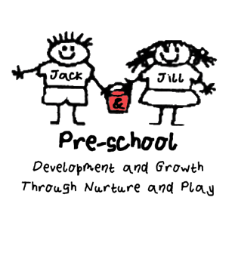
Code of Conduct

The reputation and representation of Jack & Jill Pre-school is paramount and therefore, as employees, staff represent the Pre-school and must act accordingly.
We expect all our staff to provide high levels of care and if necessary, advice to parents and other members of staff. All staff are role models for children, and we expect all staff to lead by example.

Procedures

Communication
We do not shout or raise our voices unless we believe the safety of the child is compromised. No inappropriate language or phrases will be used. We will endeavour to use a reassuring non-threatening tone and positive body language at all times. We are aware that aggressive body language or shouting presents a negative example of how we should behave as adults.

Confidentiality
We expect all staff to respect any confidential or sensitive information that they may have access to as a result of working in the Pre-School environment.

Staff are reminded not to discuss individual children, other than within the staff team for the purposes of curriculum planning/group management, with people other than the parents/guardians of that child. If a member of staff is in any doubt about the confidentiality of an issue, they should discuss their concerns with the Pre-School Leader.

Issues relating to the employment and payment of any member of staff, will remain confidential to the individual concerned and to those involved in the decision making or the administering of the process. Staff are also reminded of their obligations to respect confidentiality as detailed throughout all the sections of our Safeguarding Children Policy.

Appearance
The appearance which we present to each other, parents, carers and visitors is important. Our expectation of all Pre-school staff is that they conform to standards of dress as befits a profession. Although many styles of dress are acceptable, staff should dress appropriately for their job and give a positive image. All members of staff will be given a uniform with a logo to wear whilst they are working.

Alcohol, Drugs and Smoking
Except for medical reasons, employees must not take any substances that might affect their work. No staff should consume or be under the influence of drink/drugs during their hours of work. No smoking is permitted anywhere on the premises or in the Pre-School grounds.

Mobile Phones and Social Networking Sites
Please see separate policies.

Socialisation
If staff and parents socialise together the Pre-school, or any issues surrounding it, must not be discussed. Staff are allowed to socialise together outside work as long as they maintain confidentiality and do not discuss the Pre-school or any matters relating to the Pre-school. This includes social media, such as Facebook.
If staff are socialising outside work and see any parents they need to ensure they act appropriately and in a professional manner, they must not discuss the Pre-school or any matters relating to the Pre-school

This Policy was adopted on (date) ____________________________________

Signed By______________________________________________________

Date to be reviewed______________________________________________

