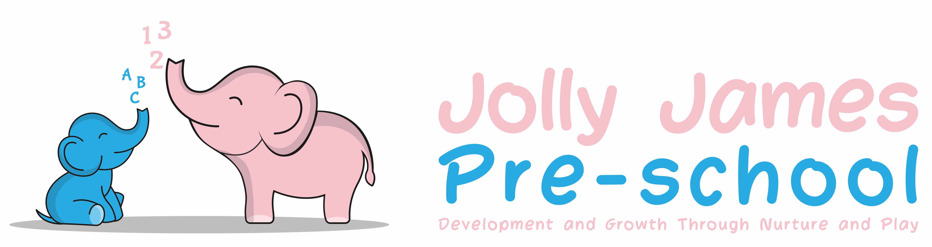

Health and safety procedures
Staff areas
- All areas are kept tidy and always uncluttered.
- Doors to staff/visitor toilets and cloakrooms are kept always shut.
- Staff are provided with an area in the office for storing personal belongings, including any medication they are taking.
- Toilet areas are not used for storage due to the risk of cross-contamination.
- Staff/visitor toilets are cleaned daily using disinfectant.
- Toilet flush handles are disinfected daily.
- There is a toilet brush provided per toilet and separate cleaning cloth.
- Toilets that are not in use are checked to ensure that the U-bend is not drying out and are flushed every week. Taps that are not in use are run for several minutes every two to three days to minimise the risk of infections such as legionella.
- Cubicle doors and handles are washed weekly.
- Staff hand basins are cleaned daily using disinfectant. Separate cloths are used to clean basins etc. and are not interchanged with those used for cleaning toilets.
- Floors in staff toilets are washed daily.
- Mirrors and tiled splash backs are washed daily.
- Paper towels or hot air dryers are provided for hand drying.
- Bins are provided for sanitary wear and cleared daily (or as per contract agreement).
- Bins are provided for disposal of paper towels and are cleared daily.
- All bins are lined with plastic bags.
- Members of staff who are cleaning toilets wear rubber gloves that are kept specifically for this purpose to prevent cross contamination.
Signed by; Hayley Culverwell, Manager
Date to be reviewed; 21/8/24

