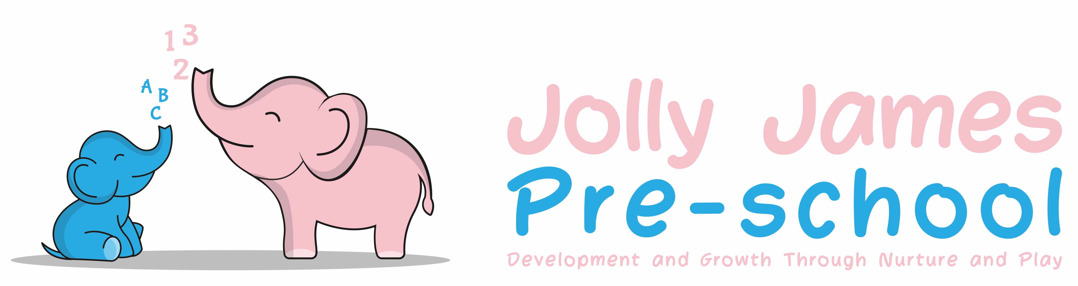
Health and Safety Policy

Policy Statement

We believe that the health and safety of children is of paramount importance. We aim to make our setting a safe and healthy place for children, parents, staff and volunteers.

Aims

- We aim to make children, parents and staff aware of health and safety issues and to minimise the hazards and risks to enable the children to thrive in a healthy and safe environment
- Our member of staff responsible for health and safety is Kathryn Slade
- She is competent to carry out these responsibilities
- We display the necessary health and safety poster on the notice board by the front door

Insurance Cover

We have public liability insurance and employer’s liability insurance. This is displayed on the notice board in the hall.

Procedures

Awareness raising

- Our induction training for staff and volunteers includes clear explanation of health and safety issues so that all adults are able to adhere to our policies and procedures as they understand their shared responsibility for health and safety
- Records are kept of inductions training sessions and new staff and volunteers are asked to sign the records to confirm that they have taken part
- Health and safety issues are explained to the parents of new children so that they understand the part played by these issues in the daily life of the setting
- As necessary, health and safety training is included in the annual training plans of staff and health and safety is discussed regularly at staff meetings
- We operate a no-smoking policy
- Children are made aware of health and safety issues through discussions, planned activities and routines

Safety of adults

- Adults are made aware about the safe storage, movement, lifting and erection of large pieces of equipment
- When adults need to reach up to store equipment they are provided with safe equipment to do so
- Staff accidents are recorded. These records are reviewed termly to identify any issues that need to be addressed
- We keep all cleaning chemicals in their original containers

Doors

- We take precautions to prevent children’s fingers from being trapped in doors

Floors

- All floor surfaces are checked daily to ensure they are clean and not uneven, wet or damaged

Kitchen

- Children do not have unsupervised access to the kitchen
- All surfaces are clean and non-porous
- Food preparation areas are cleaned before use as well as after use
- All utensils, crockery etc are cleaned and stored appropriately
- There are separate facilities for hand washing and for washing up
- Cleaning materials and other dangerous materials are stored out of reach
- When children take part in cooking activities they:
- Are supervised at all times
- Understand the importance of hand washing and simple hygiene rules
- Are kept away from hot surfaces and hot water
- Do not have unsupervised access to electrical equipment such as blenders etc

Electrical/gas equipment

- All electrical/gas equipment conforms to safety requirements and is checked regularly
- Our boiler/electrical switch gear/meter cupboard is not accessible to the children
- Storage heaters, electrical sockets, wires and leads are properly guarded and the children are taught not to touch them
- Heaters are checked daily to check that they are not covered
- There are sufficient sockets to prevent overloading
- The temperature of hot water is controlled to prevent scalds
- Lighting and ventilation is adequate in all areas including storage areas

Storage

- All resources and materials, which are used by the children, are stored safely
- All equipment and resources are stored or stacked safely to prevent them accidentally falling or collapsing

Outdoor area

- Our outdoor area is securely fenced, the main gate is locked and other gates shut during outside play
- Our outdoor area is checked for safety and cleared of rubbish before it is used
- Where water can form a pool on equipment, it is emptied before the children start playing
- Our outdoor sandpit is covered when not in use and is cleaned regularly
- All outdoor activities are supervised at all times

Hygiene

- We seek information from Health Protection Agency to ensure that we keep up to date with the latest recommendations
- Our daily routine encourages the children to learn about personal hygiene
- We have a daily cleaning routine for the setting which includes main room, back room, kitchen, toilets and nappy changing area
- We have a schedule for cleaning resources and equipment, dressing up clothes and furnishings
- The toilet area has a high standard of hygiene including hand washing and drying facilities
- Nappies are disposed of by the parents at the end of the session
- We implement good hygiene practises by:
- Cleaning tables between activities
- Cleaning toilets regularly
- Wearing protective clothing – such as aprons and disposable gloves – as appropriate
- Providing sets of clean clothes
- Providing disposable tissues and wipes
- Ensuring use of paper towels

Activities and resources

- Before purchase or loan, equipment and resources are checked to ensure that they are safe for the ages and stages of the children currently attending the Pre-school
- The layout of the equipment allows adults and children to move safely and freely between activities
- All equipment is regularly checked for cleanliness and safety and any dangerous items are repaired or discarded
- All materials, including paint and glue are non-toxic
- Sand is clean and suitable for children’s play
- Physical play is constantly supervised
- Children are taught to handle and store tools safely
- The children learn about health, safety and personal hygiene through the activities we provide and the routines we follow
- Any faulty equipment is removed from use and is repaired. If it cannot be repaired then it is discarded

Legal Framework

- Health and Safety at Work Act (1974)
- Management of Health and Safety at Work Regulations (1999)
- Electricity at Work Regulations (1989)
- Control of Substances Hazardous to Health Regulations (COSHH) (2002)
- Manual Handling Operations Regulations (1992 (as amended 2004)
- Health and Safety (Display Screen Equipment) Regulations (1992)

Further Guidance

- Five steps to Risk Assessment – www.hse.gov.uk/pubns/indg163.pdf
- Health and Safety Law: What You Should Know – www.hse.gov.uk/pubns/law.pdf
- Health and Safety Regulation...a short guide – www.hse.gov.uk/pubns/hsc13.pdf
- COSHH: A Brief guide to regulations – www.hse.gov.uk/pubns/indg136.pdf

Signed by; Hayley Culverwell, Manager

Date to be reviewed; 21/8/24

