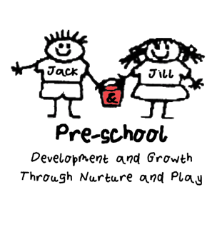
Animals in the setting
Policy Statement
Children learn about the natural world, its animals and other living creatures, as part of the Learning and Development Requirements of the Early Years Foundation Stage. This may include contact with animals, or other living creatures, either in the settings or on visits. We aim to ensure that this is in accordance with sensible hygiene and safety codes.

Procedures

Animals in the setting/animals as pets
- We carry out a risk assessment accounting for any hygiene or safety risks posed by the animal or the creature
- We provide suitable housing for the animal or creature and ensure this is cleaned out regularly and is kept safely
- We ensure the correct food is offered, at the right times
- We make arrangements for weekend and holiday care for the animal
- Children are taught correct handling and care of the animal or creature whilst supervised
- Children wash their hands after handling the animal or creature and do not have contact with animal soil or soiled bedding
- Staff wear disposable gloves when cleaning housing or handling soiled bedding
- If animals or creatures are brought in by visitors to show the children, they are the responsibility of their owner
- The owner carries out a risk assessment, detailing how the animal or creature is to be handled and how any safety issues will be addressed

Legal Framework
- The management of Health and Safety at Work Regulations (1999)

Further Guidance
- Health and Safety Regulation…A Short Guide (HSE 2003)

This Policy was adopted on (date) ____________________________________

Signed By______________________________________________________

Date to be reviewed______________________________________________

