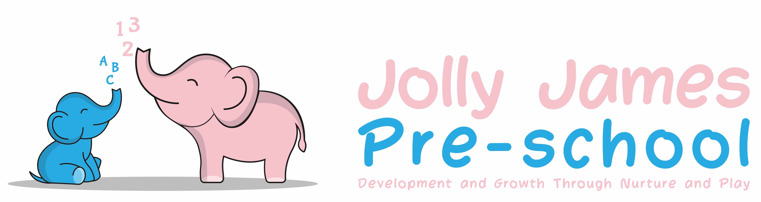

Health and safety procedures
Kitchen
General safety
- Doors to the kitchen are kept always closed.
- Shutters to hatches are kept closed when cooking is taking place.
- Children do not have unsupervised access to the kitchen.
- Children are not taken to the kitchen when meal preparation is taking place.
- Staff do not normally take tea breaks in the kitchen unless there is no alternative, in which case, tea-breaks are not taken in the kitchen when food is being prepared.
- Wet spills are mopped immediately.
- A clearly marked and appropriately stocked First Aid box is kept in the kitchen.
Cleanliness and hygiene
Staff follow the recommended cleaning schedules in Safer Food Better Business (SFBB).
- Floors are washed down at least daily.
- All work surfaces are washed regularly with anti-bacterial agent.
- Inside of cupboards are cleaned monthly.
- Cupboard doors and handles are cleaned regularly.
- Fridge and freezer doors are wiped down regularly
- Washing up is done by hand in double sinks, where possible, one to wash, one to rinse.
- Where possible all crockery and cutlery are air dried.
- Plates and cups are only put away when fully dry.
- Tea towels, if used, are used once. They are laundered weekly.
- Any cleaning cloths used for surfaces are washed and replaced daily.
- There is a mop, bucket, broom, dustpan, and brush set aside for kitchen use only.
- Any repairs needed are recorded and reported to the manager / owner.
- Chip pans are not used.
Further guidance
Safer Food Better Business: Food safety management procedures and food hygiene regulations for small business: www.food.gov.uk/business-guidance/safer-food-better-business

Signed by; Hayley Culverwell, Manager

Date to be reviewed; 21/8/24

