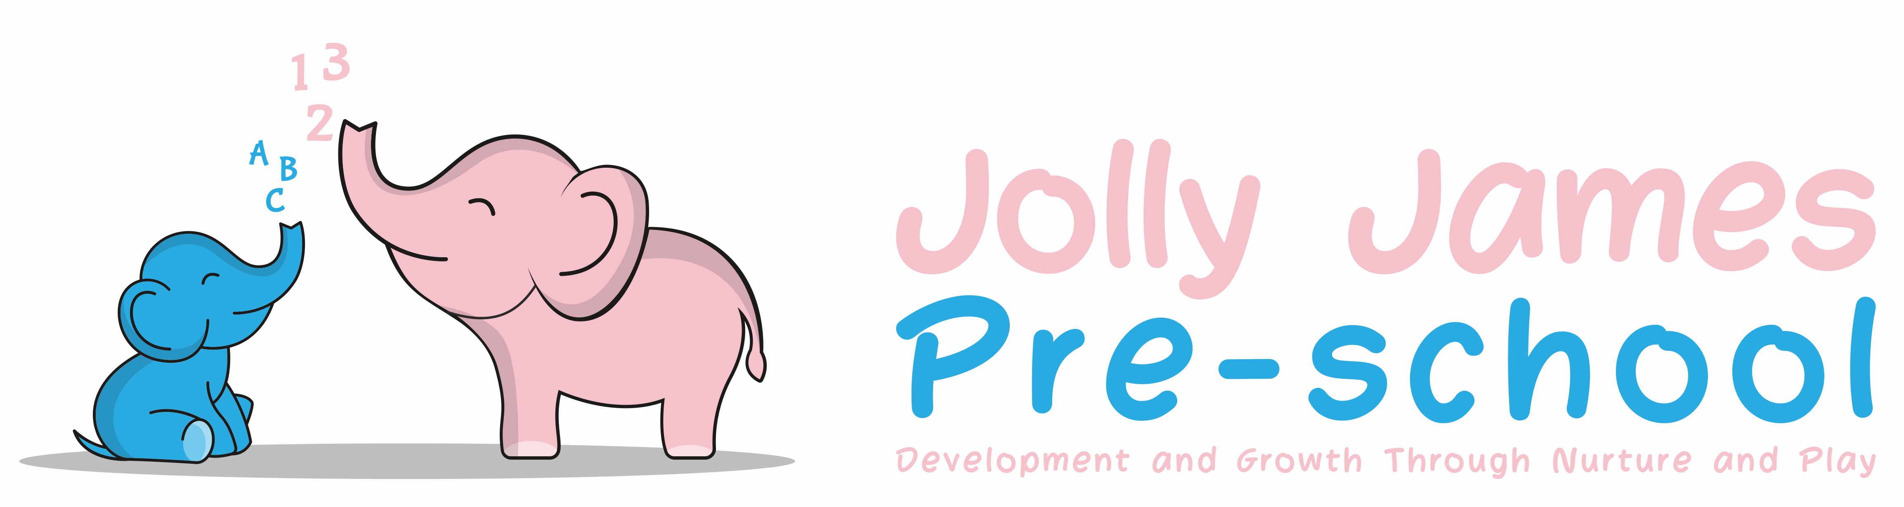
Valuing diversity and promoting equality

Policy statement

At Jolly James Pre-School we aim to ensure that our service is fully inclusive in meeting the needs of all children, particularly those that arise from their ethnic heritage, social and economic background, gender, ability or disability. Our setting is committed to anti-discriminatory practice to promote equality of opportunity and valuing diversity for all children and families. At Jolly James Pre-School we will not discriminate against a child or adult with disabilities and we will make reasonable adjustments for them.

Aims

We aim to:

- Provide a secure and accessible environment in which all our children can flourish and in which all contributions are considered and valued
- Include and value the contribution of all families to our understanding of equality and diversity
- Provide positive non-stereotyping information about gender roles, diverse ethnic and cultural groups and those with a disability
- Improve our knowledge and understanding of issues of anti-discriminatory practice, promoting equality and valuing diversity and make inclusion a thread that runs through all the activities of the setting
- Challenge and eliminate discriminatory actions
- Foster good relations between all communities

Procedures

Admissions

Our setting is open to all families in the community and we provide information in a clear, concise language, whether in spoken or written form.

- We have a separate admissions policy
- We advertise our service within the community
- We reflect the diversity of our society in our publicity and promotional materials
- We provide information in clear, concise language, whether in spoken or written form
- If required, we will aim to provide information in as many languages as possible
- We do not discriminate against a child or their family, or prevent entry to our setting, on the basis of disability, colour, ethnicity, religion or social background, such as being a member of a Travelling Community or an asylum seeker
- We develop an action plan or make reasonable adjustments to ensure that people with disabilities can participate successfully in the services offered by the setting and the curriculum offered
- We take action against any discriminatory behaviour by staff or parents. Displaying of openly discriminatory and possibly offensive materials, name calling or threatening behaviour are unacceptable on or around the premises and will be dealt with in the strongest manner.
- A waiting list is in operation; the child will be placed on the waiting and will be allocated a place in the following order of priority, when a place is available.
          - Those that have been on the waiting list longest
          - Siblings

Employment

- Posts are advertised and all applicants are judged against explicit and fair criteria
- Applicants are welcome from all backgrounds and posts are open to all
- We may use the exemption clauses in relevant legislation to enable the service to best meet the needs of the community
- The applicant who best meets the criteria is offered the post, subject to references and checks by the Criminal Records Bureau. This ensures fairness in the selection process
- All job descriptions include a commitment to promoting equality and recognising and respecting diversity as part of their specifications
- We monitor our application process to ensure that it is fair and accessible

Training

- We seek out training opportunities for staff and volunteers to enable them to develop anti-discriminatory and inclusive practices, which enable our children to flourish
- We ensure that staff are confident and fully trained in administering relevant medicines and performing invasive care procedures when these are required.
- We review our practices to ensure that we are fully implementing our policy for equality, diversion and inclusion

Curriculum

The curriculum offered in the setting encourages children to develop positive attitudes about themselves as well as to people who are different from themselves. It encourages children to empathise with others and to begin to develop the skills of critical thinking.

Our environment is as accessible as possible for all users, although we acknowledge that not all children with a disability have a special educational need we have regard for the Disability Discrimination Act (1995) and will make reasonable adjustments to include all children and their families. We do this by:

- Making children feel valued and good about themselves
- Ensuring that children have equality of access to learning
- Making adjustments to the environment and resources to accommodate a wide range of learning, physical and sensory impairments
- Making appropriate provision within the curriculum to ensure each child receives the widest possible opportunity to develop their skills and abilities, e.g. recognising the different learning styles of boys and girls
- Avoiding stereotypes or derogatory images in the selection of books or other visual materials
- Celebrating a wide range of festivals
- Creating an environment of mutual respect and tolerance
- Differentiating the curriculum to meet children’s special educational needs
- Helping children to understand that discriminatory behaviour and remarks are hurtful and unacceptable
- Ensuring that the curriculum offered is inclusive of children with special educational needs and children with disabilities
- Ensuring that children learning English as an additional language have full access to the curriculum and are supported in their learning

Our curriculum is carefully planned on a weekly basis to ensure that the Seven Areas of Learning and Development (as specified in The Early Years Foundation Stage) are covered.

All parents/carers are welcome to discuss the weekly plans however newsletters are sent out weekly.

Staff know the children at Pre-school very well, keyworkers know their own children implicitly, regular observations on all children are made by staff throughout their session. From this, effective individual plans for each child can be planned, ensuring that each child can develop their skills in the most appropriate way. By monitoring progress individually, we can best effect early identification and response to needs which might lead to development or learning difficulties.

Valuing diversity in families

- We welcome the diversity of family lifestyles and work with all families
- We encourage children to contribute stories of their everyday life to the setting
- We encourage mothers, fathers and other carers to take part in the life of the setting and to contribute fully
- For families who speak languages in addition to English, we will develop means to ensure their full inclusion

To ensure that our policies and procedures remain effective we will monitor and review them annually to ensure our strategies meet the overall aims to promote equality, inclusion and valuing diversity.

We provide a complaints procedure and a complaints summary record for parents to see.

Food

- We work in partnership with parents to ensure that dietary requirements of children that arise from their medical, religious or cultural needs are met
- We help children to learn about a range of food, and of cultural approaches to mealtimes and eating, and to respect the differences among them

Legal framework

- The Equality Act 2006, 2010
- Disability Discrimination Act 1995, 2005
- Race Relations Act 1976
- Race Relations Amendment Act 2000
- Sex Discrimination Act 1976, 1986
- Children Act 1989, 2004
- Special Educational Needs and Disability Act 2001

Signed By: Hayley Culverwell

Date to be reviewed: 21/8/24

