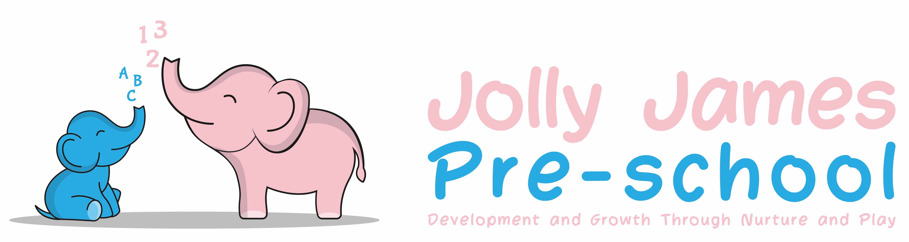
Safeguarding Children
Complaints Policy

Policy Statement

At Jolly James Pre-school we believe that all children and parents are entitled to expect courtesy and prompt, careful attention to their needs and wishes. We welcome suggestions on how to improve our setting and will give prompt and serious attention to any concerns about the running of the setting. We anticipate that most concerns will be resolved quickly by an informal approach to the appropriate member of staff. If this does not achieve the desired result, the following procedures will be used.

Procedures

We will keep a record of all complaints that reach level two or beyond. This is available to parents as well as Ofsted inspectors.

Stage 1
- Any parent who has any concerns or feels they have cause for complaint are advised to speak to the Pre-school manager.
- At this stage most complaints are usually resolved informally and amicably

Stage 2
- If this does not have a satisfactory outcome, or the problem recurs, the parent is advised to put their concerns or complaint in writing to the manager.
- The written complaint will be stored in the child’s file. However, if the complaint involves a detailed investigation, the setting manager may wish to store all information relating to the investigation in a separate file designated for this complaint
- When the investigation into the complaint is completed, the setting manager will meet with the parents to discuss the outcome
- All written complaints will be investigated within 28 days of having received the complaint
- When the complaint is resolved at this stage, the summative points are logged in the Complaints Summary Record

Stage 3
- If the parent is not satisfied after the investigation in stage 2 a meeting is requested with the Pre-School manager, both parent and manager should have another person present if required
- An agreed written record of the discussion is made as well as any decision or action to take as a result. All parties present at the meeting sign the record and receive a copy of it
- The signed record signifies that the procedure has concluded. When the complaint is resolved at this stage, the summative points are logged in the Complaints Summary Record

Stage 4
- If after the stage 3 meeting an agreement cannot be reached, an external mediator is called in to settle the complaint. This person should be acceptable to both parties and listen to both sides and offer advice. The mediator has no legal powers but can help define the problem, review the action so far and suggest further ways in which it might be resolved
- The mediator keeps all discussions confidential. He/she can hold separate meetings with the Pre-school personnel and the parent, if this is deemed to be helpful
- The mediator keeps an agreed written record of any meetings that are held and of any advice he/she gives

Stage 5
- When the mediator has concluded the investigation, a final meeting will be held to reach a decision on the action to be taken to deal with the complaint. The mediator’s advice is used to reach this conclusion. The mediator is present at the meeting if all parties think this will help a decision to be made
- A record of this meeting, including the decision on the action to be taken is made. Everyone present at the meeting signs the record and receives a copy of it. This signed record signifies the procedure has concluded

The role of the Office for Standards in Education, Children’s Services and Skills (Ofsted) and the Local Safeguarding Children Board

- Parents may approach Ofsted directly at any stage of this complaint's procedure. In addition, where there seems to be a possible breach of the setting’s registration requirements, it is essential to involve Ofsted as the registering and inspection body with a duty to ensure the Welfare Requirements of the Early Years Foundation Stage are adhered to
- The number to call Ofsted with regards to a complaint is 0300 123 1231
- These details are displayed on our notice board
- If a child appears to be at risk, our setting follows the procedures of the Local Safeguarding Partnership set out by Buckinghamshire County Council.
- In these cases, both the parent and setting are informed, and the setting manager works with Ofsted of the Local Safeguarding Partnership to ensure a proper investigation of the complaint, followed by appropriate action

Records
- A record of complaints against Jolly James Pre-school and/or the children and /or the adults working in the Pre-School are kept, including the date, the circumstances of the complaint and how the complaint was managed
- The outcome of all the complaints are recorded in the summary complaints record which is available for parents and Ofsted inspectors on request

Parents can contact Ofsted on:
Ofsted
Piccadilly Gate
Store Street
Manchester
M1 2WD
Telephone: 0300 123 1231

Signed By; Hayley Culverwell, Manager

Date to be reviewed; 21/8/24

